Software engineering for big data analaysis

CSA-1035

EXP NO: 26

1. Make a class diagram to model for a quiz system. A user can request a quiz for the system. The system picks a set of questions from its database, and composes them together to make a quiz. It rates the user’s answers and gives hints if the user requests it. In addition to users, we also have helpers who provide questions and hints. And also administrators who must certify questions to make sure they are not too trivial and those they are correct.

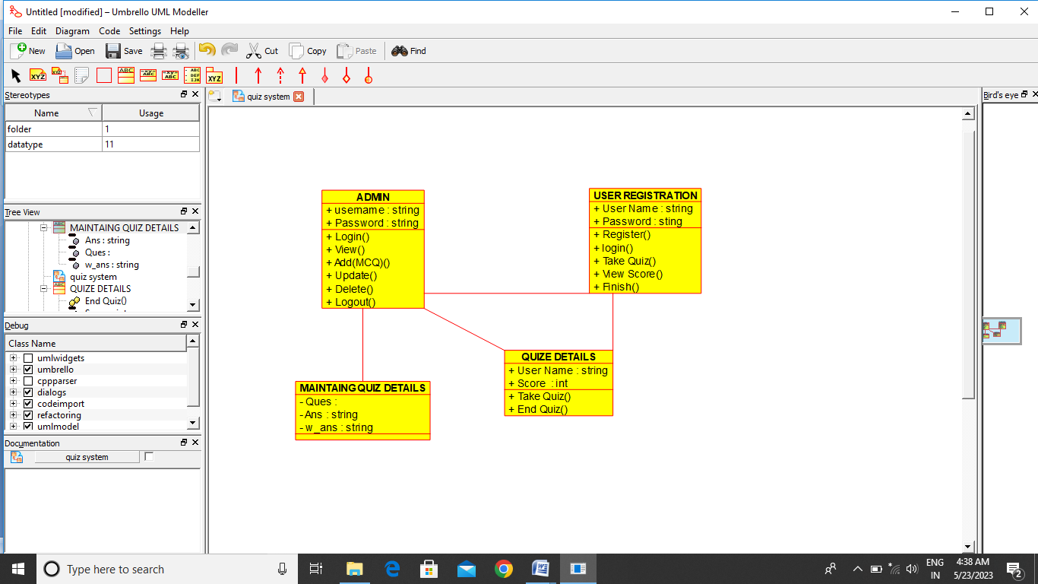

Result:-

Thus the class daigram for quiz system is drawn and verified successfully